Name: Class:
Introduction
Aspirin is one of the oldest drugs known to society. Like many drugs, aspirin must be used carefully. For many years several companies marketed aspirin in Australia. Now our aspirin supplies are imported. The synthesis of aspirin provides an example of the use and importance of functional groups in drug synthesis.

No. | Question | Answer
 | Aspirin is effective as an analgesic, an antipyretic and an anti-inflammatory drug. What do each of these terms mean? | .
 | Willow bark (salicylic acid) has long been used as a pain reliever. Use the Internet to research the history of use of willow bark as a pain reliever. Briefly report your findings.
Name the functional groups (circled) present in the salicylic acid and aspirin molecules shown below.
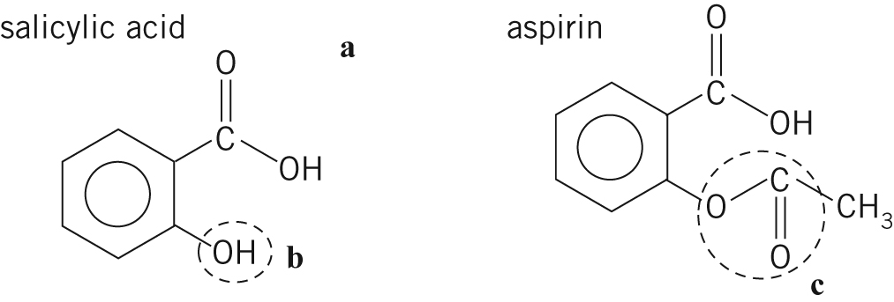

 | The commercial process for the manufacture of aspirin uses the reaction between acetic acid and salicylic acid. Write an equation for this reaction, using structural diagrams.
 | The laboratory process for making aspirin uses acetic (ethanoic) anhydride, (CH₃CO)₂O, instead of acetic acid. Use structural diagrams to show clearly the reaction that occurs between acetic anhydride and salicylic acid in the presence of sulfuric acid.
a What is the role of the sulfuric acid in the reaction in question 5?
b Name another reaction for which sulfuric acid has this role.
Each aspirin tablet contains
325 mg of aspirin held together by an inert binder, usually starch.
a Why is a binder used?
b Why is starch used as a binder?
a What mass (in kg) of salicylic acid is required to make
1 million aspirin tablets (assuming 100% efficiency)?
b Is it likely the process will be close to 100% efficient?

 | What happens if you take too much aspirin?
 | In the preparation of aspirin, it is the OH group of the salicylic acid that reacts. Write an equation using structural formulas for the reaction that occurs when the –COOH group of the acid reacts with methanol in the presence of an acid catalyst.

